**INTRODUCTION**

Overview:

Economic freedom is the fundamental right of every human to control his or her own labor and property. In an economically free society, individuals are free to work, produce, consume, and invest in any way they please. In economically free societies, governments allow labor, capital, and goods to move freely, and refrain from coercion or constraint of liberty beyond the extent necessary to protect and maintain liberty itself. For much of human history, most individuals have lacked economic freedom and opportunity, condemning them to poverty and deprivation. Economic indicators measure everything from economic growth to changes in prices to unemployment. The markets can move on news about key economic indicators. Information provided by economic indicators can help us to make decisions about our investments.

Purpose:

Economic indicators help us to consider trades in the context of economic events and understand price actions during these events. We do not need advanced knowledge of economics to make use of an economic calendar, as not every single data release must be analyzed in-depth. The economic freedoms and accompanying historical data also provide a comprehensive set of principles and facts for those who wish to understand the fundamentals of economic growth and prosperity.

PROBLEM DEFINITION & DESING THINKING:

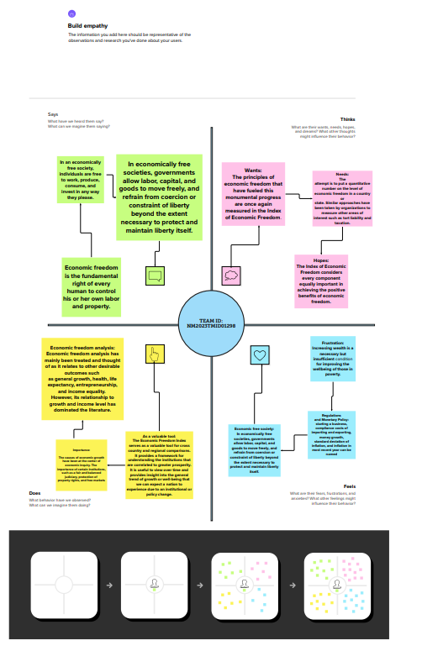Empathy map:

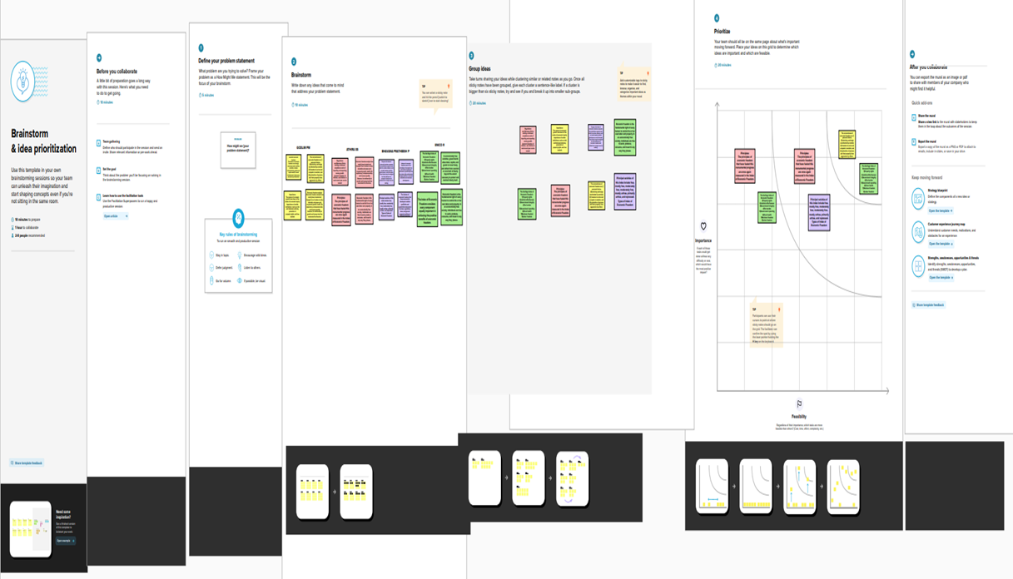Ideation & Brainstorming Map:

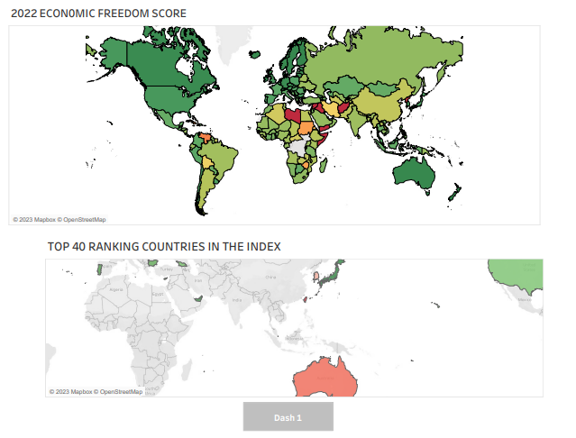Result:

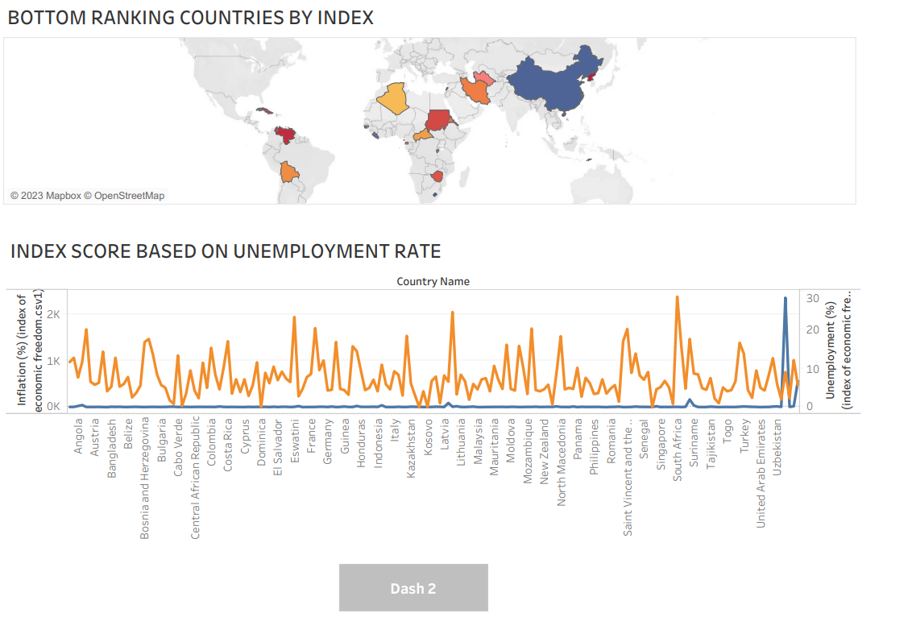Dashboard 2

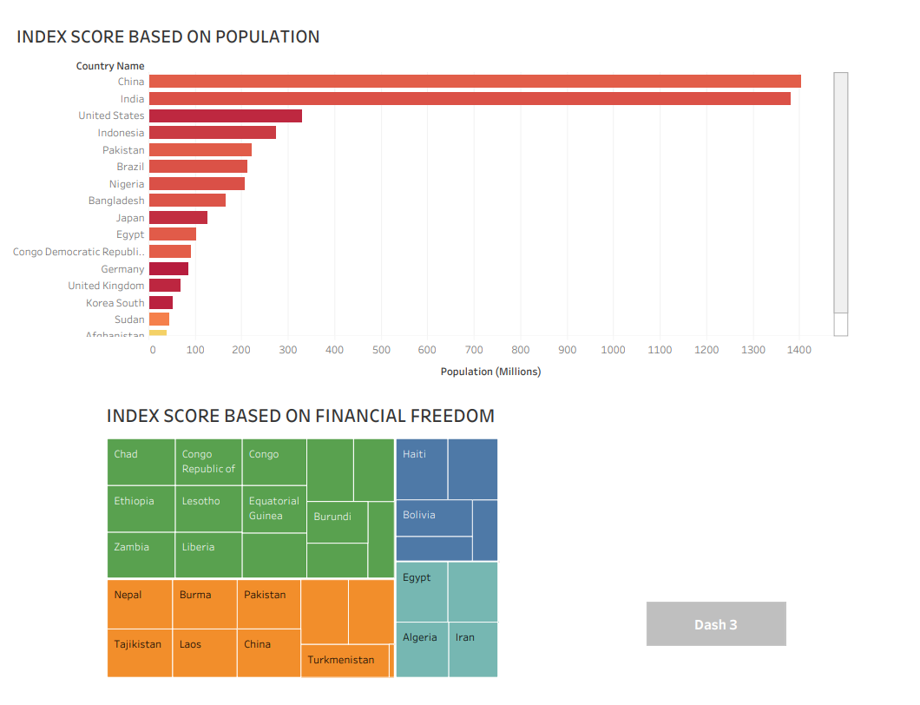Dashboard3:

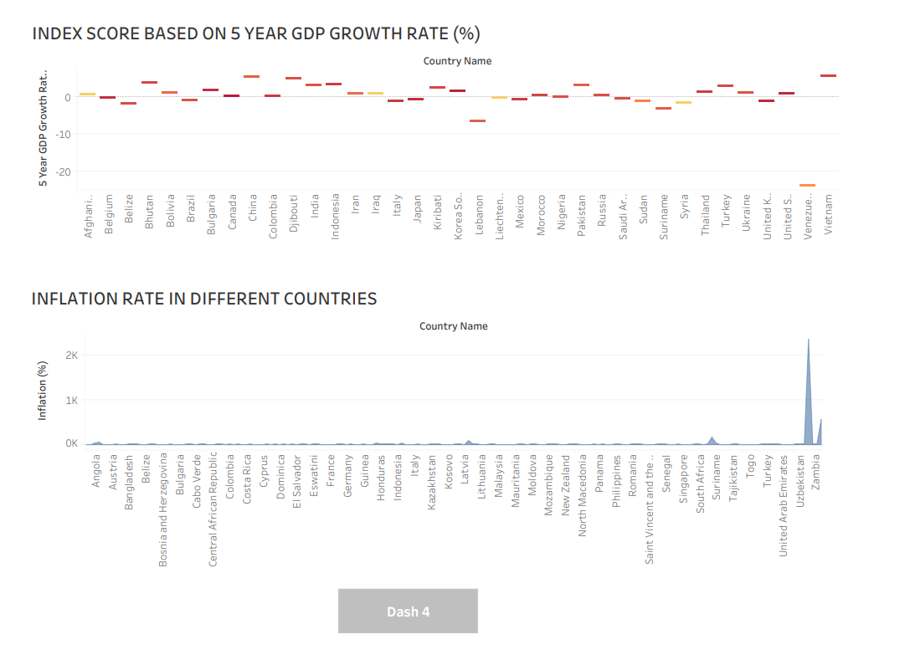Dashboard 4

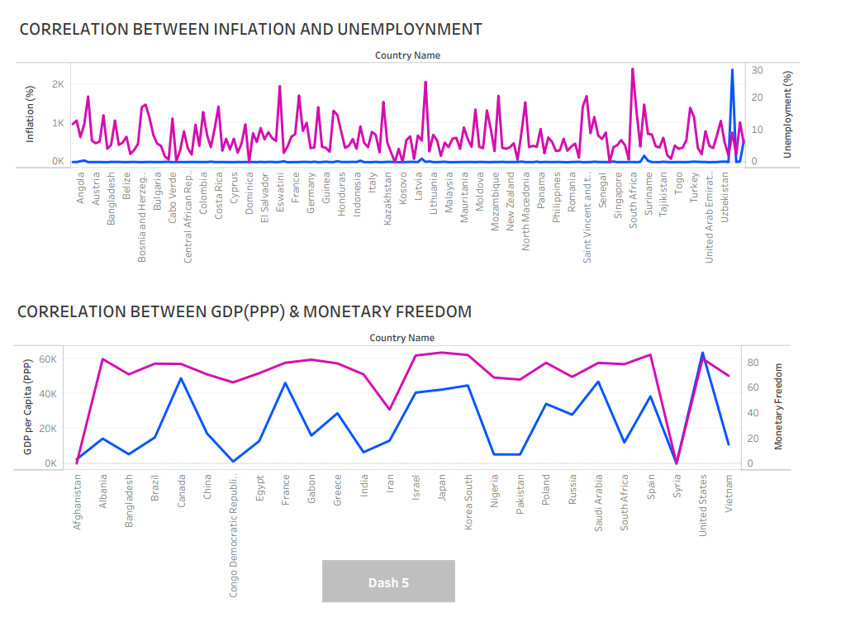Dashboard 5:

Dashboard 6:

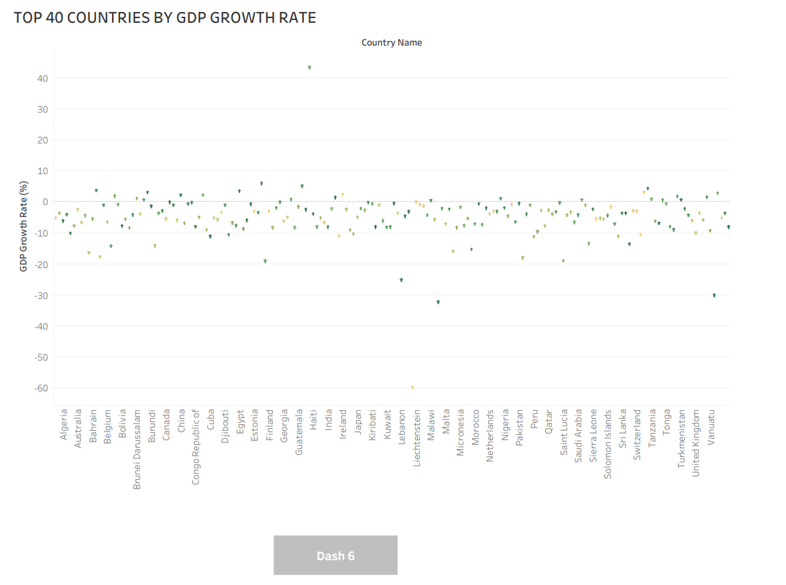

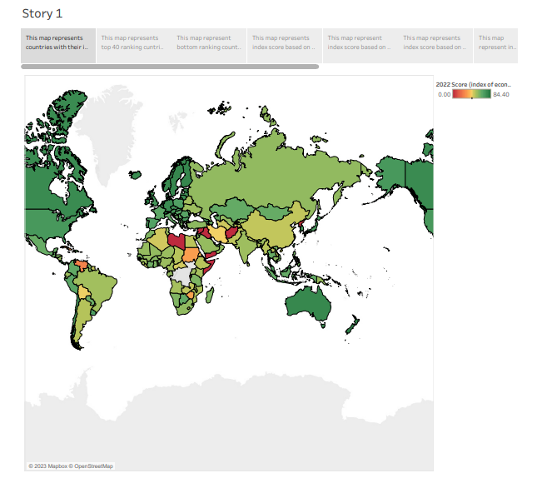Story:

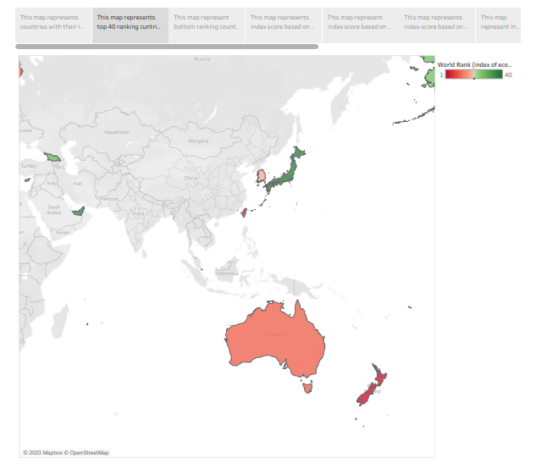

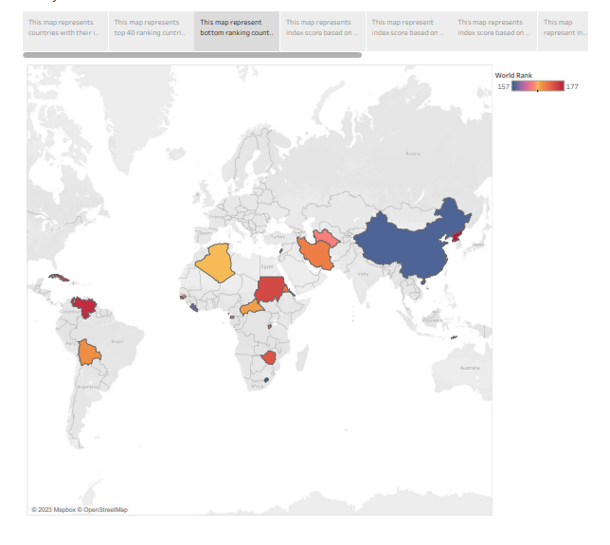

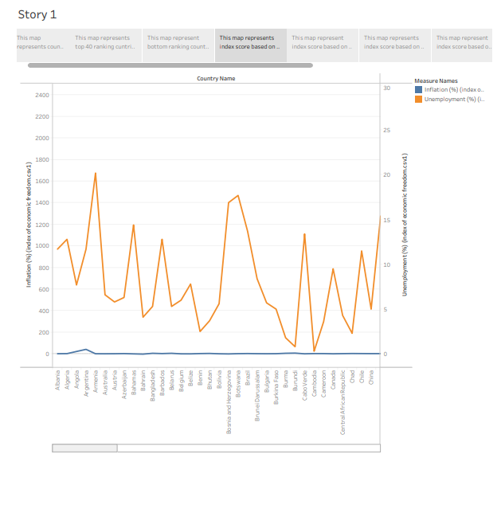

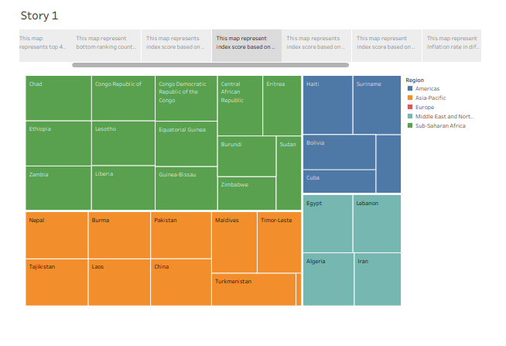

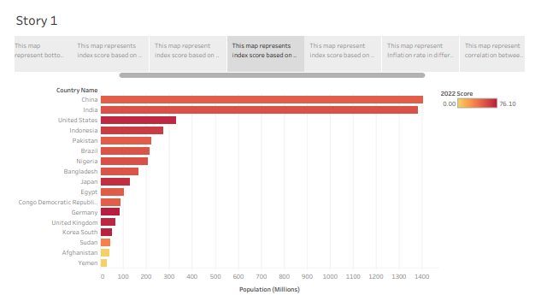

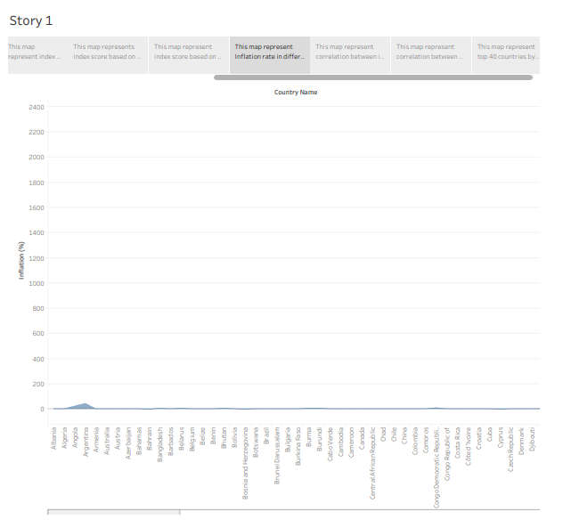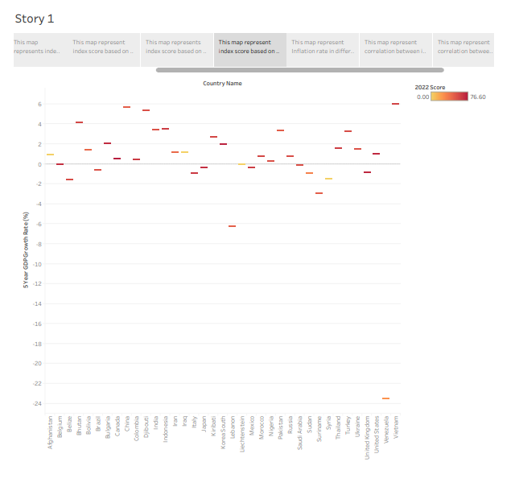

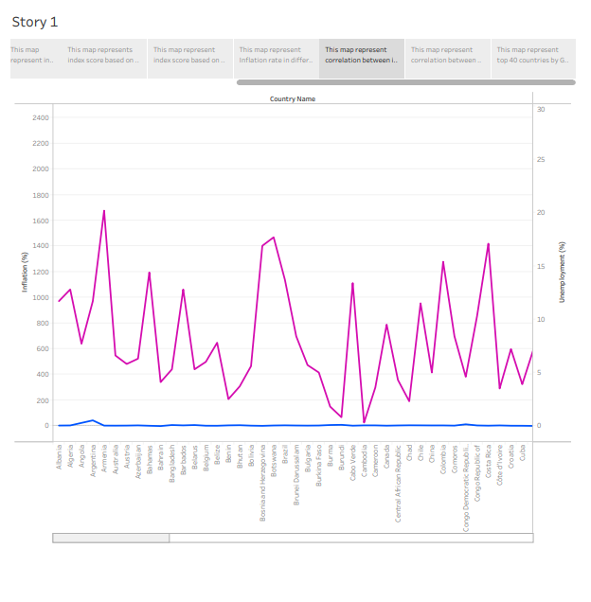

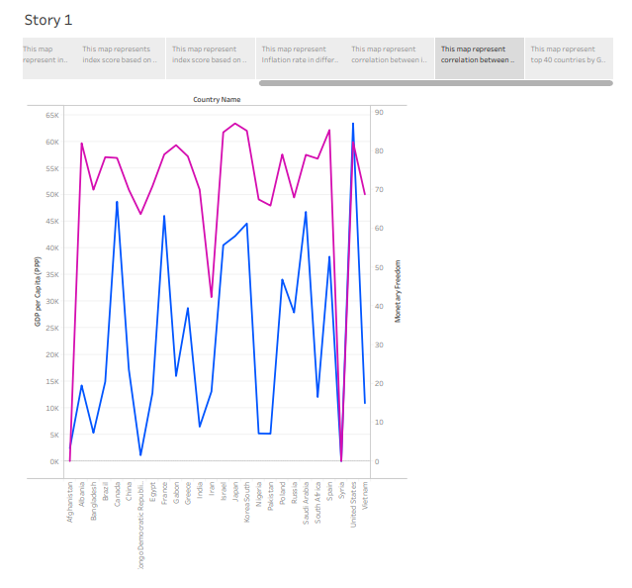

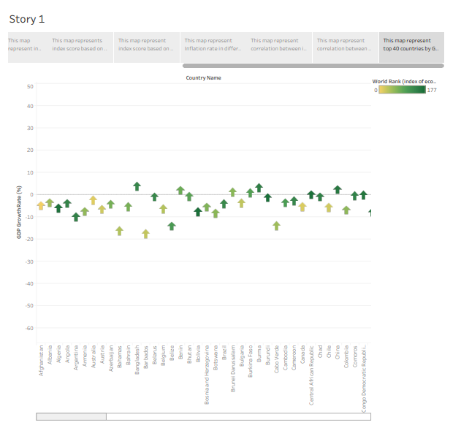

**Advantages & Disadvantages**

* Economic is a helpful economic indicators help us to consider trades in the context of economic events and understand price actions during these events. We do not need advanced knowledge of economics to make use of an economic calendar, as not every single data release must be analyzed in-depth.
* Economic indicators measure everything from economic growth to changes in prices to unemployment. The markets can move on news about key economic indicators. Information provided by economic indicators can help people make decisions about their investments. The Index of Economic Freedom tool for a variety of audiences, including academics, policymakers, journalists, students, teachers, and those in business and finance.
* The Index is an excellent objective tool for analyzing 184 economies throughout the world and each country page is a resource for in-depth analysis of a country’s political and economic developments. The economic freedoms and accompanying historical data also provide a comprehensive set of principles and facts for those who wish to understand the fundamentals of economic growth and prosperity.

**Applications:**

Economic is a helpful economic indicators help us to consider trades in the context of economic events and understand price actions during these events. We do not need advanced knowledge of economics to make use of an economic calendar, as not every single data release must be analyzed in-depth. Economic indicators measure everything from economic growth to changes in prices to unemployment. The markets can move on news about key economic indicators. Information provided by economic indicators can help people make decisions about their investments. The Index of Economic Freedom tool for a variety of audiences, including academics, policymakers, journalists, students, teachers, and those in business and finance. The Index is an excellent objective tool for analyzing 184 economies throughout the world and each country page is a resource for in-depth analysis of a country’s political and economic developments. The economic freedoms and accompanying historical data also provide a comprehensive set of principles and facts for those who wish to understand the fundamentals of economic growth and prosperity.

**Conclusion:**

The Index of Economic Freedom is a helpful tool for a variety of audiences, including academics, policymakers, journalists, students, teachers, and those in business and finance. The Index is an excellent objective tool for analyzing 184 economies throughout the world and each country page is a resource for in-depth analysis of a country’s political and economic developments. The 12 economic freedoms and accompanying historical data also provide a comprehensive set of principles and facts for those who wish to understand the fundamentals of economic growth and prosperity.

**Future Scope:**

* The size of the government, public expenditure, taxes, influence on the economy
* The legal structure which guarantees the right to own
* The access to a healthy currency
* Freedom in international trade
* Regulation of costs, work and economy

**~~~~~**